Legal and Regulatory Analysis

Year: _2023_ Semester: __Spring_______ Team: __8__ Project:__Engineer’s Chess_______

Creation Date: March 22, 2023 Last Modified: March 22, 2023

Author: ___Tyson Kline____________________ Email: ____kline62@purdue.edu_______

Assignment Evaluation:

| **Item** | **Score (0-5)** | **Weight** | **Points** | **Notes** |
| --- | --- | --- | --- | --- |
| **Assignment-Specific Items** | | | | |
| **Regulatory Analysis** |  | x3 |  |  |
| **Analysis of Patent 1** |  | x3 |  |  |
| **Analysis of Patent 2** |  | x3 |  |  |
| **Analysis of Patent 3** |  | x3 |  |  |
| **Writing-Specific Items** | | | | |
| **Spelling and Grammar** |  | x2 |  |  |
| **Formatting and Citations** |  | x1 |  |  |
| **Figures and Graphs** |  | x2 |  |  |
| **Technical Writing Style** |  | x3 |  |  |
| **Total Score** |  | | |  |

5: Excellent 4: Good 3: Acceptable 2: Poor 1: Very Poor 0: Not attempted

Comments:

*Comments from the grader will be inserted here.*

1.0 Regulatory Analysis

Engineer’s chess will fall within the scope of several regulatory agencies. It also could be affected by a few others. These agencies that would definitely have an interest in this product include the IEC, UL, and FCC. If we were to market our product internationally, we would also need to conform to the standards of the CE and RoHS regulatory agencies. Finally, if we conformed to FIDE standards our design would be usable in official chess games. Because our device does not go into the air, it is not regulated by the FAA, and because no part of the device is related to health and the body it is not regulated by the FDA. The requirements necessary to meet the previously listed regulatory agencies can be seen below.

**1.1 IEC Compliance**

The International Electrotechnical Commission regulates nearly all electronic devices by providing standards to be met for certification. In the event that we developed our device into a finished product, there are a few steps we would need to take to receive IEC certification. The first step would be to modify our project to meet the standards set on the IEC website [1]. The next step would be to receive a conformity assessment to verify that we meet these standards. This assessment can be done by us, or it can be done by an independent party, which is the preferred method. Once this is complete, we will have IEC certification

**1.2 UL Compliance**

The Underwriter’s Laboratory tests products for safety before they go to market. In order to be certified by UL, we would have to contact them to arrange for a test of our product. UL would need to test multiple samples of our device, so we would need to produce more production level devices before we completed this test. Once we have passed the tests given by UL, we would be UL certified.

**1.3 FCC Compliance**

The Federal Communications Commission regulates any device that communicates via radio waves or produces EMI in any way. While our product does not use radio waves, it does have a high frequency clock, so we would need to get our product FCC certified. Our device would be a Class B device labeled as an unintentional radiator. In order to get our device certified, we would need to complete a test to ensure that our device is not outputting signals that may interfere with other radio signals.

**1.4 CE Compliance**

Conformité Européenne ensures that all products comply with EU laws that set standards for electrical devices. Our device barely falls under CE jurisdiction, as the only covered area present in our device is a capability of generating EMI. In order to be certified with CE, the same steps would need to be covered as previously mentioned for FCC.

**1.5 RoHS Compliance**

Restriction of Hazardous Substances is an EU legislation dedicated to restricting the use of hazardous materials in electronic products. This is not a large issue because our product contains little to no hazardous materials. All solder is lead-free. The only step necessary to meet these standards would be to have our product officially certified.

**1.6 FIDE Compliance**

The International Chess Federation is an organization dedicated to managing professional, competitive chess. Their website [] contains the top-ranked players and multiple resources detailing their chess rules. In order to meet FIDE standards and allow our product to be used in official matches, we would need to ensure that our game logic adheres to the official FIDE rules.

2.0 Legal Liability Analysis

2.1 Analysis of Patent 1: Interactive Play Apparatus

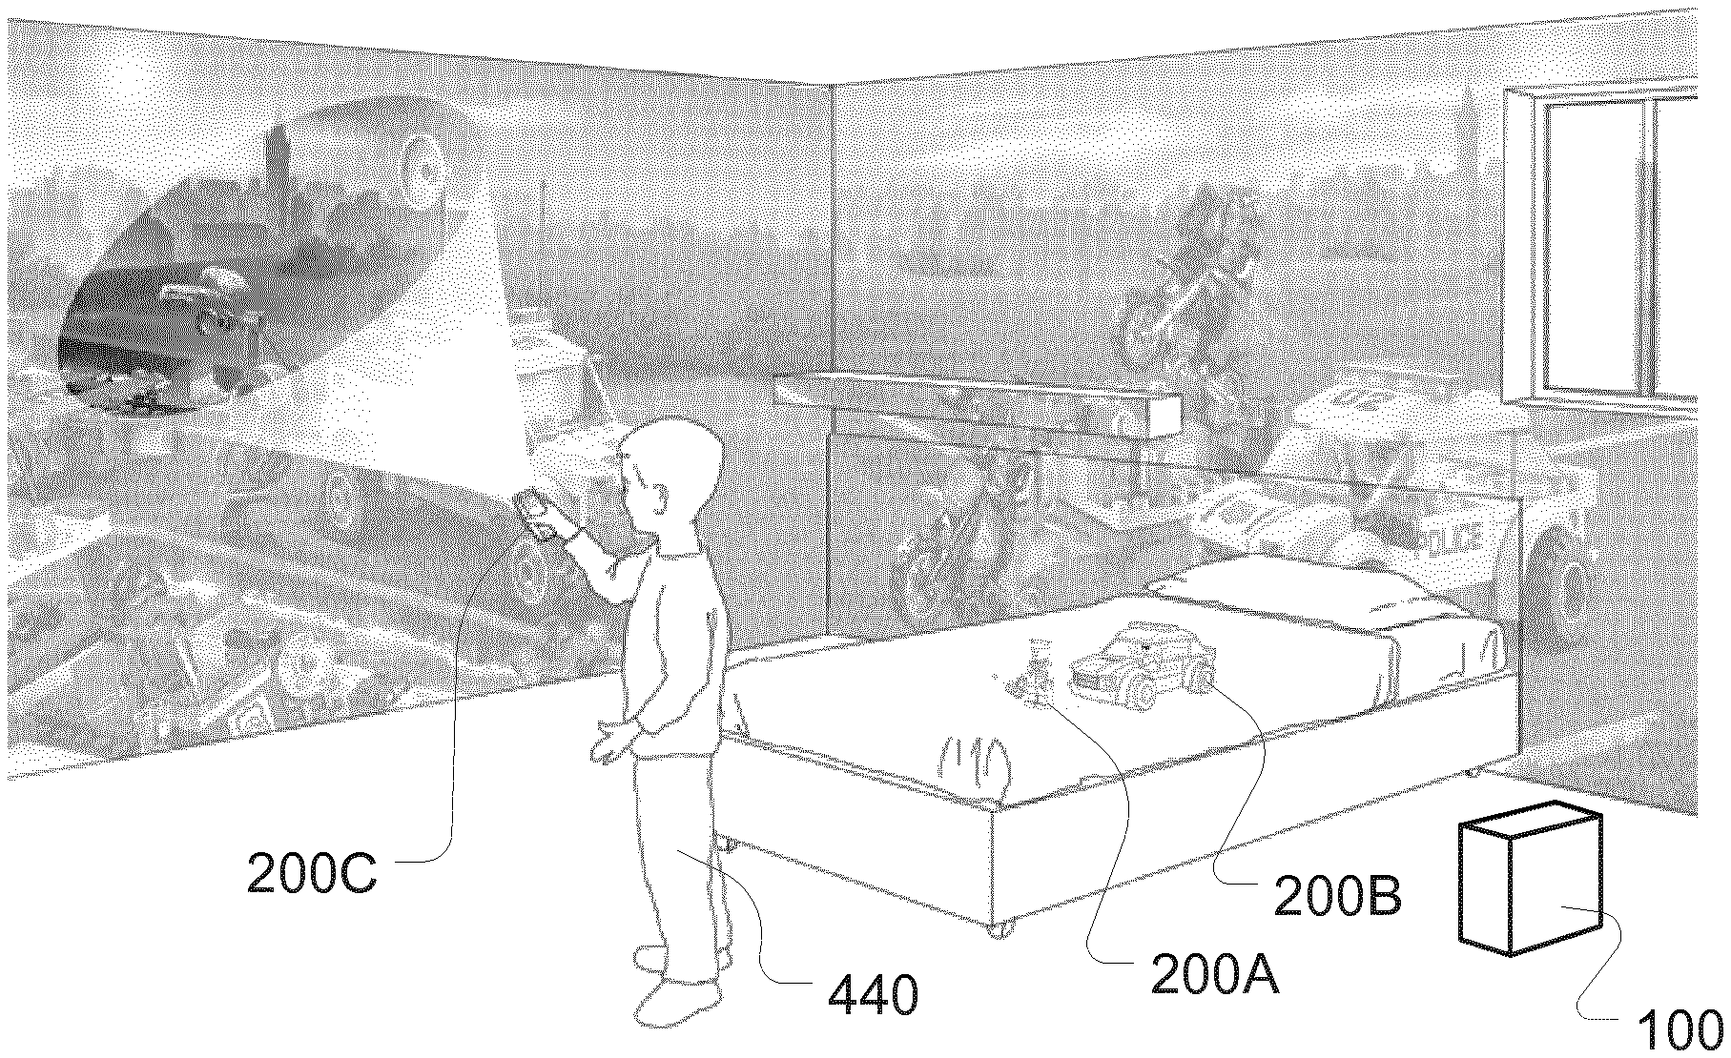

This patent [3], filed by Apple Inc on May 29th, 2020, relates to the use of electronic devices with voice control. As such, this gives the users of said devices the ability to manipulate the device with their voice in addition to regular functions. It also relates to determining actions based on the voice input given. One key claim that provides the potential for infringement is a design consisting of, “an input device configured to receive an input; one or more communications interfaces; one or more processors” [3]. This clearly relates to the function of our design.

It is unlikely that there would be a literal or doctrine-of-equivalents infringement of this patent. The specifications that overlap are very vague and broad. Both designs perform substantially the same function, taking in voice input and using it for play data, but they do it in substantially different ways. The patented design accomplishes this using several sensors and processors, while our design has a simple filtering and amplifying system using an audio jack as input.

2.2 Analysis of Patent 2: Electronic Game Board

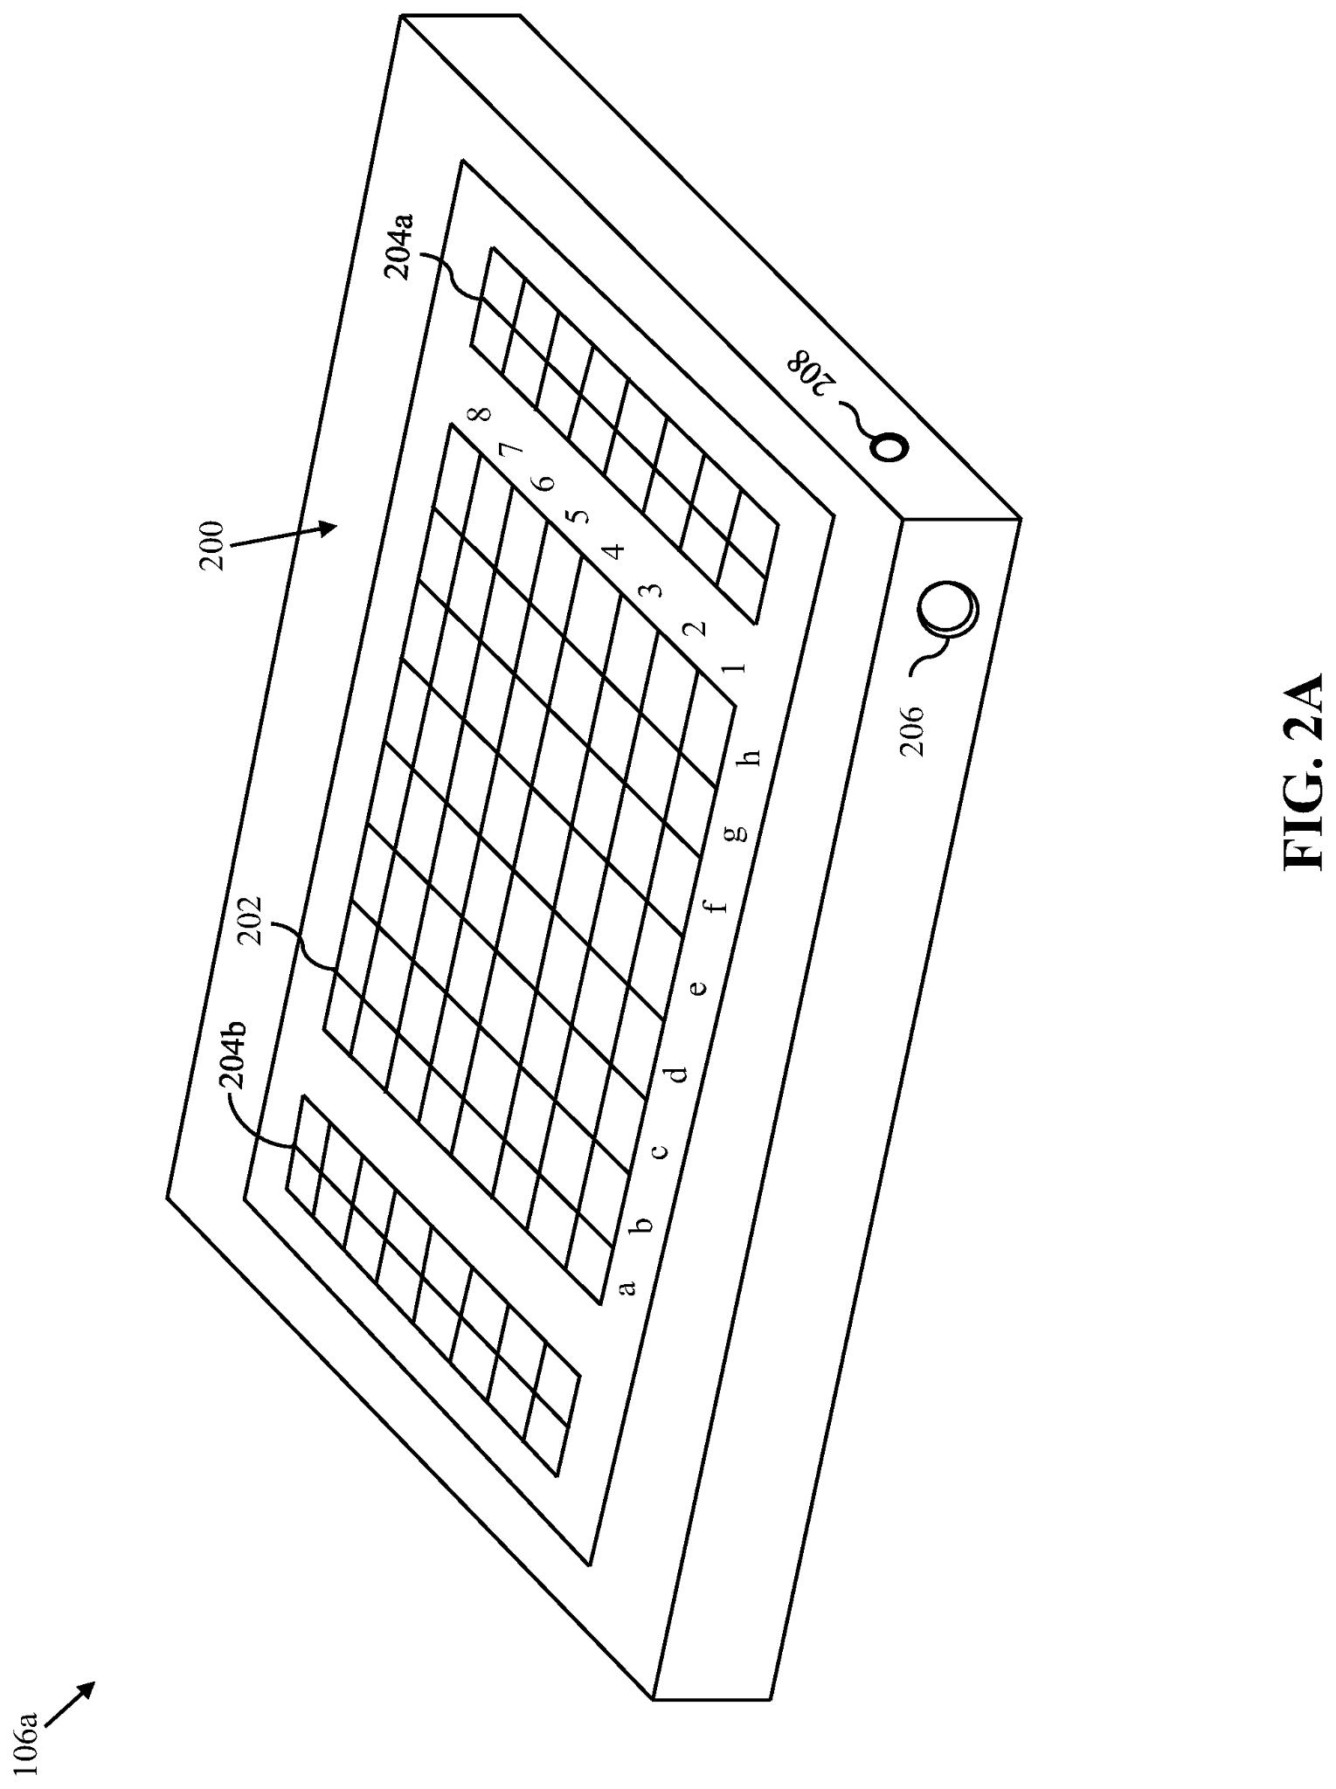

This patent [4], filed by Infivention Technologies Pvt Ltd on October 10th, 2019, details an electronic game board used for multiple games. It consists of a main play board where pieces are arranged and moved. This particular patent uses a robot arm to move pieces around and play the game. A key claim that could lead to infringement is “A gom board, comprising: a top cover including at least a play area onto which … game pieces are arranged for facilitating a game” [4]. This is related to our method of displaying our game.

Our design is unlikely to infringe on this patent. While both the patent and our design have the same function (displaying game pieces on a main board), they are accomplished in vastly different ways. The patent describes physical pieces moved using a robot arm, and our project consists of LED-displayed pieces moved using voice commands.

2.3 Analysis of Patent 3: Set of Chess Pieces

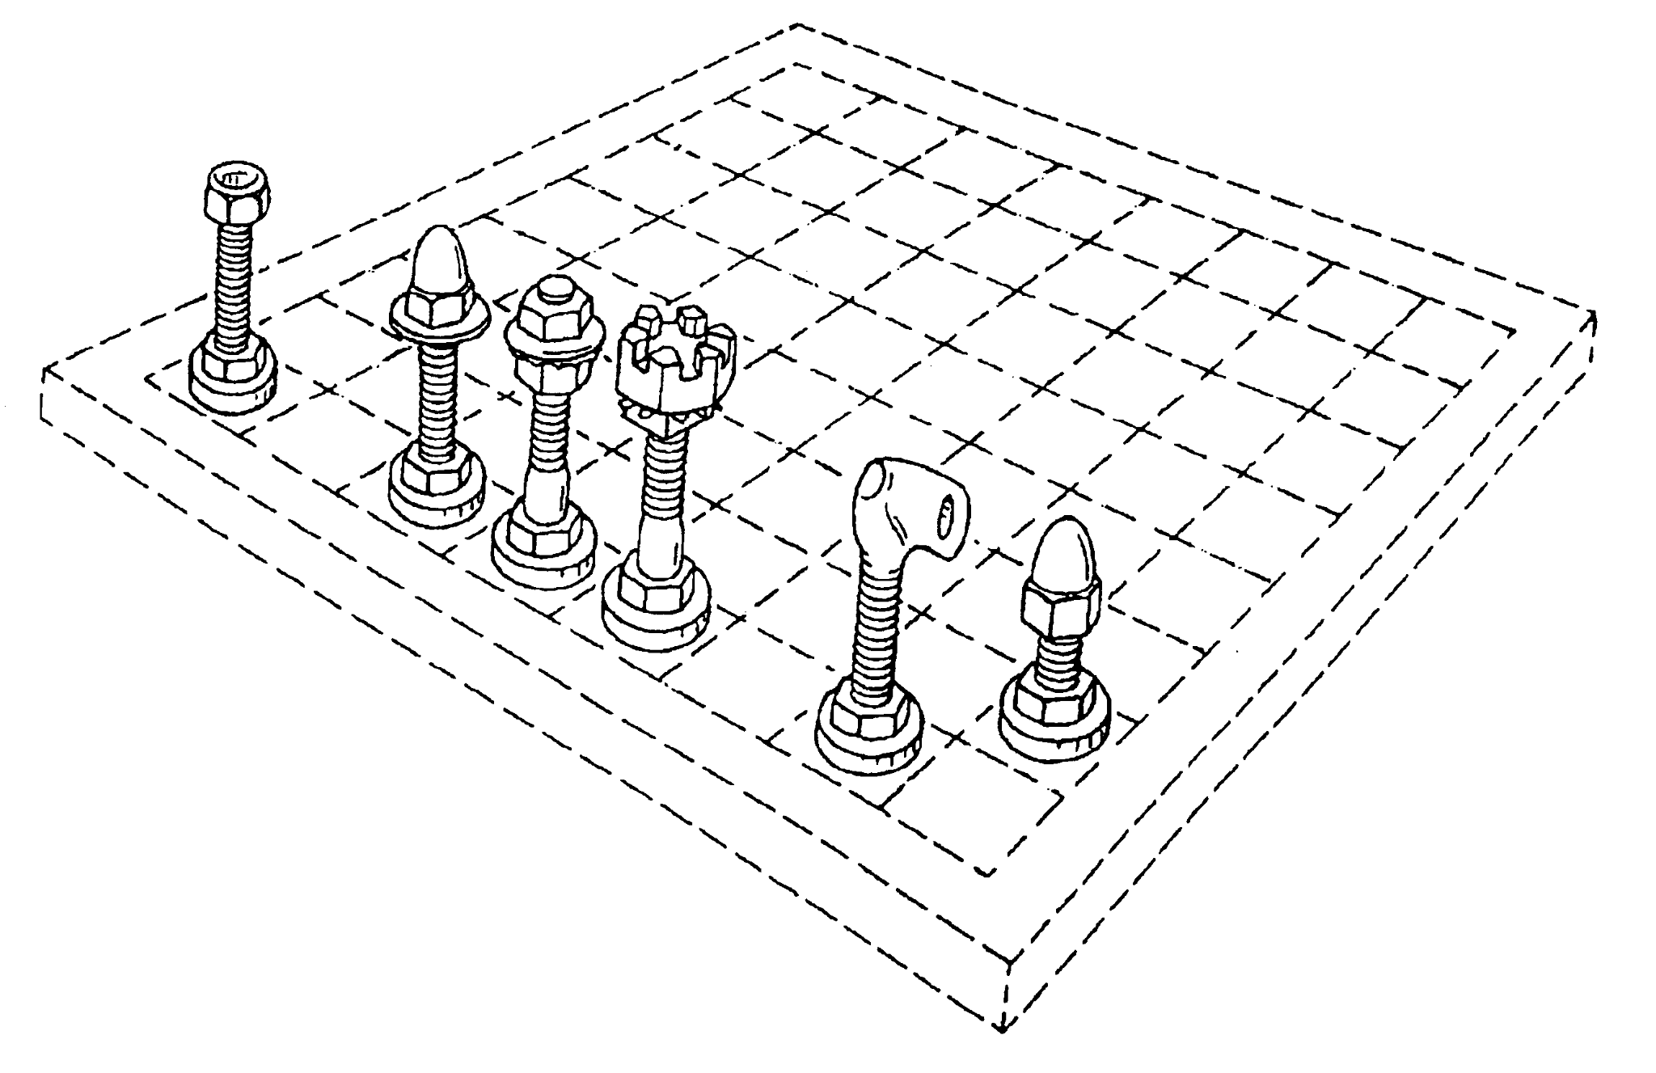

This patent [5], filed by Steven Malkovich on March 10th, 2004, is a design patent for a specific chess set design. This patent is an excellent example of certain designs we need to be aware of as we design our project. This particular patent includes custom designs for the king, queen, bishop, knight, rook, and pawn. Possible infringement could be claimed if our project’s design was deemed too close to the design shown in the patent.

Our project is unlikely to have literal or doctrine-of-equivalents infringement of this patent. While both the patent and our project have the exact same function of providing a visual to distinguish between chess pieces, the two achieve this in different ways. The patented design uses physical, highly detailed pieces, while our design uses simple pixelated pieces using an LED display.

3.0 Sources Cited:

[1] “Conformity assessment,” *IEC*. [Online]. Available: <https://www.iec.ch/conformity-assessment>

[2] *International Chess Federation*. [Online]. Available: <https://www.fide.com/>

[3] E. Hansen, J. Søderberg, T. Donaldson, and M. Jensen, “US11433302B2 - interactive play apparatus,” *Google Patents*, 16-Oct-2018. [Online]. Available: <https://patents.google.com/patent/US11433302B2/en?oq=11433302>

[4] A. M. Mehta, D. K. Gehlot, and B. H. Gohil, “US20200282297A1 - Electronic Game Board,” *Google Patents*, 10-Oct-2019. [Online]. Available: <https://patents.google.com/patent/US20200282297A1/en?oq=20200282297>

[5] S. Malkovich, “USD513770S1 - set of Chess Pieces,” *Google Patents*, 10-Mar-2004. [Online]. Available: <https://patents.google.com/patent/USD513770S1/en?q=%28chess%29&country=US&language=ENGLISH&type=DESIGN&oq=%28chess%29%2Bcountry%3AUS%2Blanguage%3AENGLISH%2Btype%3ADESIGN>